

**IBM – NALAIYA THIRAN PROJECT**  

**GLOBAL SALES DATA ANALYTICS**

**PROJECT REPORT**

**INDUSTRY MENTOR : SHANAWAZ ANWAR**

**FACULTY MENTOR : SUJARITHA M**

**TEAM ID : PNT2022TMID02707**

**TEAM LEAD : HARISH NJ (19EUCS041)**

**TEAM MEMBER : BHARATH V (19EUCS023)**

**TEAM MEMBER : AZAGHU VENKATESH (19EUCS020)**

**TEAM MEMBER : KANISHKA D (19EUCS058)**

**SRI KRISHNA COLLEGE OF ENGINEERING AND TECHNOLOGY**

**(An Autonomous Institution, Affiliated to Anna University Chennai - 600 025)**

**NOVEMBER 2022**



**BONAFIDE CERTIFICATE**

Certified that this project report titled **“GLOBAL SALES DATA ANALYTICS ”** is the bonafide work of **Mr. HARISH NJ(19EUCS041) , Mr. BHARATH V (19EUCS023) , Mr. AZAGHU VENKATESH(19EUCS020) ,**

**Miss .KANISHKA D(19EUCS058)** who carried out the project work under my supervision.

**SIGNATURE SIGNATURE**

**Dr.K. SASI KALA RANI, M.E., Ph.D., Dr.M.SUJARITHA,M.E.,Ph.D.,**

**HEAD OF THE DEPARTMENT SUPERVISOR**

Department of Computer Science and Engineering

Sri Krishna College of Engineering and Technology

Kuniamuthur,Coimbatore

**Submitted for the Project viva-voce examination held on___________**

**INTERNAL EXAMINER EXTERNAL EXAMINER**

**TABLE OF CONTENTS**

|  |  |  |
| --- | --- | --- |
| **CHAPTER NO.**  **1** | **TITLE**  **LIST OF FIGURES**  **INTRODUCTION** | **PAGE NO**  **V**  **1** |
|  | 1.1 Project Overview | 1 |
|  | 1.2 Purpose | 1 |
| **2** | **LITERATURE SURVEY** | **2** |
|  | 2.1 Existing problem | 2 |
|  | 2.2 References | 2 |
|  | 2.3 Problem Statement Definition | 3 |
| **3** | **IDEATION & PROPOSED SOLUTION** | **4** |
|  | 3.1 Empathy Map Canvas | 4 |
|  | 3.2 Ideation & Brainstorming | 5 |
|  | 3.3 Proposed Solution | 6 |
|  | 3.4 Problem Solution fit | 6 |
| **4** | **REQUIREMENT ANALYSIS** | **7** |
|  | 4.1 Functional requirement | 7 |
|  | 4.2 Non-Functional requirements | 8 |
| **5** | **PROJECT DESIGN** | **9** |
|  | 5.1 Data Flow Diagrams | 9 |
|  | 5.2 Solution & Technical Architecture | 9 |
|  | 5.3 User Stories | 10 |
| **6** | **PROJECT PLANNING & SCHEDULING** | **12** |
|  | 6.1 Sprint Planning & Estimation | 12 |
|  | 6.2 Sprint Delivery Schedule | 13 |
|  | 6.3 Reports from JIRA | 13 |
| **7** | **CODING & SOLUTIONING** | **14** |
|  | 7.1 Feature 1 | 14 |
|  | 7.2 Feature 2 | 15 |
| **8** | **TESTING** | **16** |
|  | 8.1 Test Cases | 16 |
|  | 8.2 User Acceptance Testing | 16 |
| **9** | **RESULTS** | **18** |
|  | 9.1 Performance Metrics | 18 |
| **10** | **ADVANTAGES & DISADVANTAGES** | **19** |
| **11** | **CONCLUSION** | **20** |
| **12** | **FUTURE SCOPE** | **20** |
| **13** | **APPENDIX** | **21** |
|  | Source Code | 21 |
|  | GitHub & Project Demo Link | 34 |

**LIST OF FIGURES**

|  |  |  |
| --- | --- | --- |
| **FIGURE NO.** | **TITLE** | **PAGE NO.** |
| **1.1** | **Empathy Map** | **4** |
| **1.2** | **Problem Statement & Brainstorm** | **5** |
| **1.3** | **Group Ideas & Prioritize** | **5** |
| **1.4** | **Problem Solution fit** | **6** |
| **2.1** | **Data Flow Diagram** | **9** |
| **2.2** | **Architecture diagram** | **10** |
| **3.1** | **Sprint Delivery Schedule** | **13** |
| **3.2** | **Sprint Report** | **13** |
| **4.1** | **Performance Metrics** | **18** |

**INTRODUCTION**

* 1. **OVERVIEW**

Shopping online is currently the need of the hour. Because of this COVID, it's not easy to walk in a store randomly and buy anything you want. So, try to understand a few things like, Customer Analysis and Product Analysis of this Global Super Store. Customer analytics (or consumer analytics for B2C) is the process of collecting and analyzing behavioral customer data across a range of channels, devices, and interactions. These analytics give you the insight necessary to form strategies, products, and services that your customers will want to engage with.

* 1. **PURPOSE**

To visualize the Customer Analysis and Product Analysis of this Global Super Store and by the end of this Project, the User gets clarify with:

* Fundamental concepts of IBM Cognos Analytics.
* Gain a broad understanding of plotting different visualizations to provide a suitable solution.
* Able to create meaningful Visualizations and Dashboard(s).

**LITERATURE SURVEY**

**2.1 EXISTING PROBLEM**

Shopping online is currently the need of the hour. Because of this COVID, it's not easy to walk in a store randomly and buy anything you want. So, try to understand a few things like, Customer Analysis and Product Analysis of this Global Super Store.

**2.2 REFERENCES**

For References we inferred a few project papers:

* Digital Transformation of IKEA’s by Rama Krishna Ponnana; Navya Uppalapati
* Evaluation of Business Continuity Management - A case study of disaster recovery during the Covid-19 pandemic by Fredrik Tegström; Filip Nilsson.
* How to integrate the Purchase with Sales and Operation planning process by Matilda Davidson; Frida Hannson.
* A Theory of Predictive Sales Analytics Adoption by Sasha Alavi; Nicolas Heinitz.

**2.3 PROBLEM STATEMENT DEFINITION**

Every store be it online or offline needs evaluation and analysis to predict daily sales. It's also essential to know what goods customers want at a particular time and what the trend would be every day, month and year. The major focus of this analysis is to understand some things. Like Sales Trend, Most Selling Products by Number of Sales, Least Selling Product by Number of Sales, Shipping Mode by Sales, Profitable Categories, Numbers of Product Sold by Category, Cities with Highest Sales Top Selling Products by Amount of Sales. Analysis of the sales data with particular focus given to how promotions and advertising translate into sales, in terms of both units sold and sales dollars. Usually, Data Redundancy might happen or missing of data when we do it manually. So, we should aim to answer some basic questions that may arise for the store manager/owner/customers giving a much better insight about the store and how to increase the productivity.

**IDEATION & PROPOSED SOLUTION**

**3.1 EMPATHY MAP CANVAS**

* An empathy map is a simple, easy-to-digest visual that captures knowledge about a user’s behaviors and attitudes.
* It is a useful tool to helps teams better understand their users.
* Creating an effective solution requires understanding the true problem and the person who is experiencing it.
* The exercise of creating the map helps participants consider things from the user’s perspective along with his or her goals and challenges.

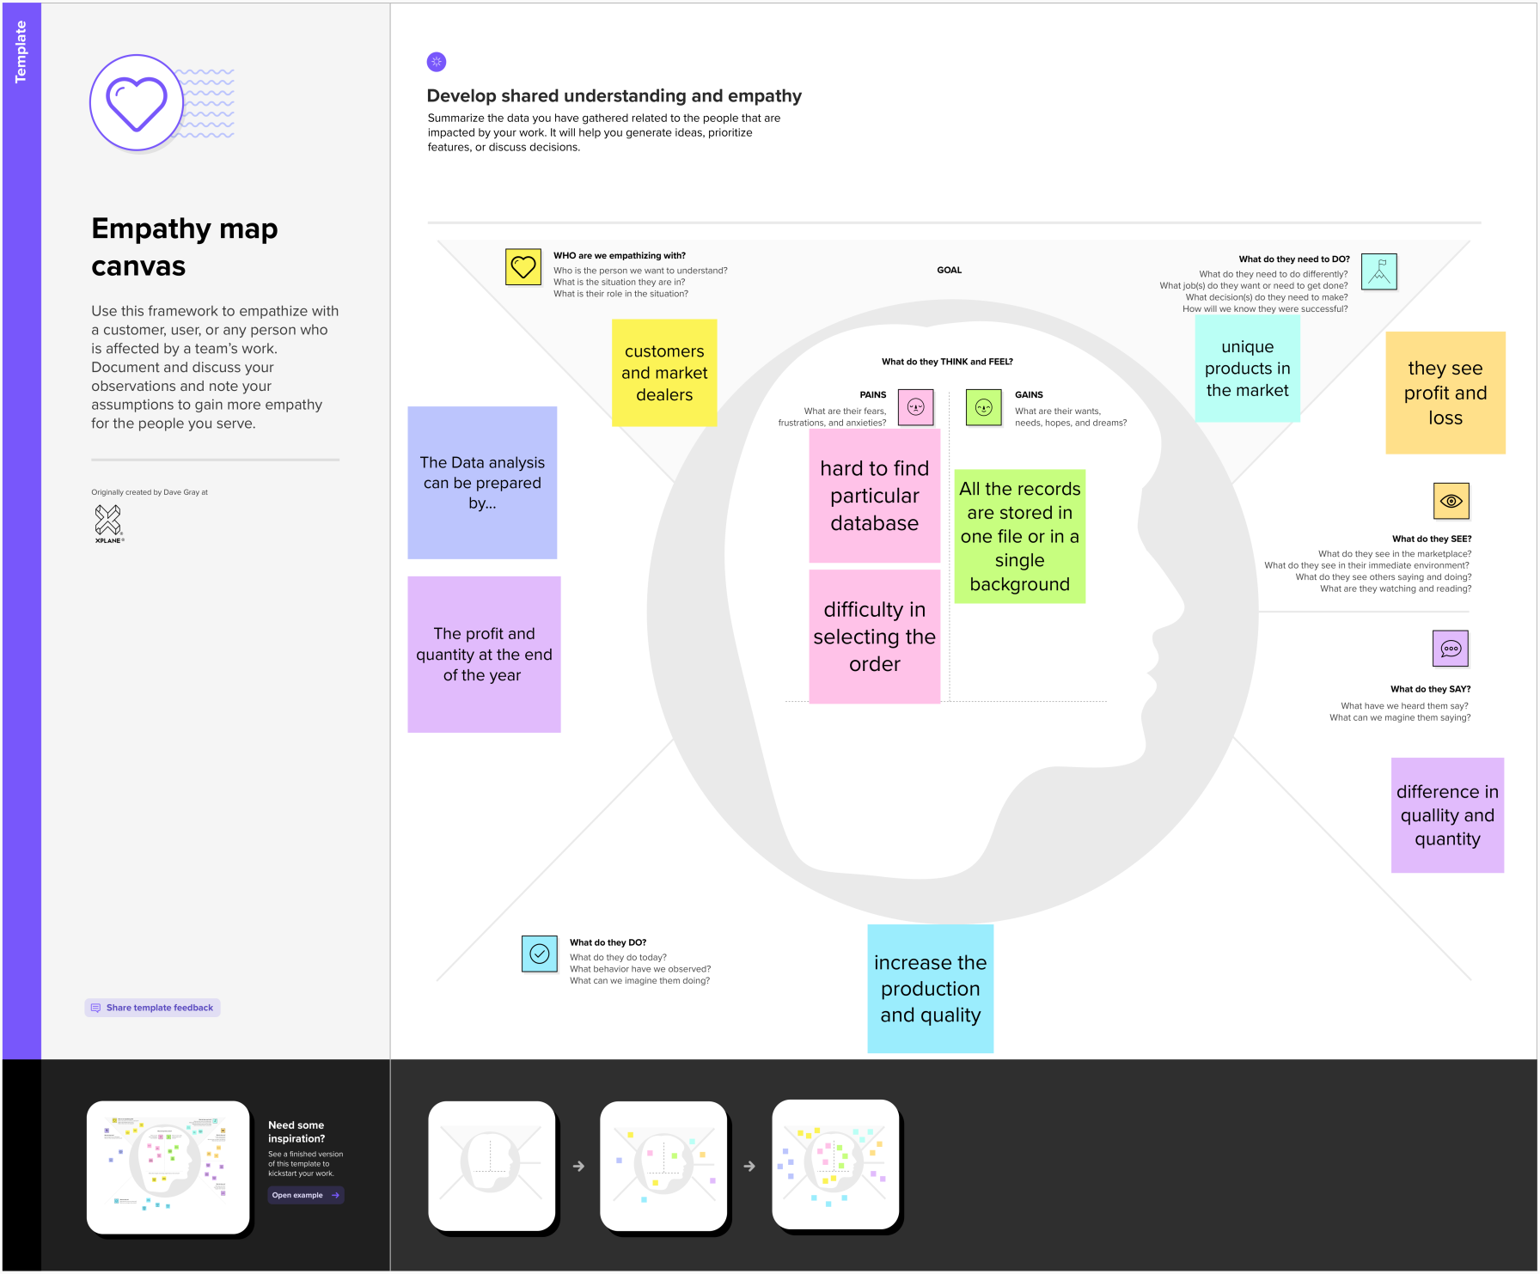

**Fig 1.1.Empathy Map**

**3.2 IDEATION & BRAINSTORMING**

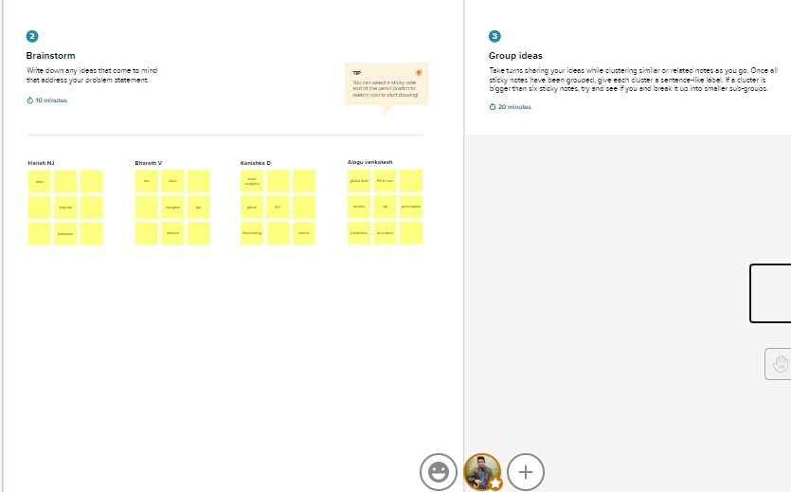

**Fig 1.2.Problem Statement & Brainstorm**

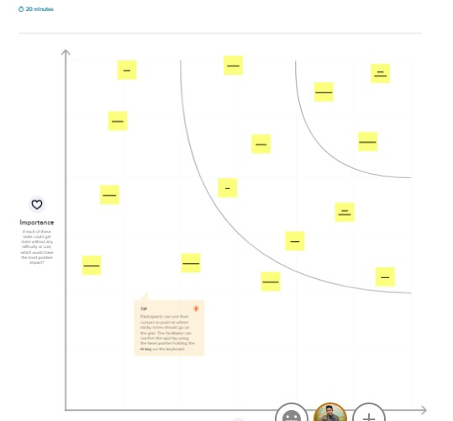

**Fig 1.3.Group Ideas & Prioritize**

**3.3 PROPOSED SOLUTION**

The major focus of this Project is to understand the Sales and Purchases Data by the Customer and Buyer all around the world. Thus, by providing a Data Visualization Chart, one can discover the recent Trends in Data and saves time. Also, Data Visualization Provides a Perspective or Usefulness on the Data. The solution is found in three steps,

Which is:

* Selection of Right Analytic Tool
* Using eye appealing and narrative Dashboards.
* Choosing the Right Metrics in our Dataset to showcase the Trends.

Hence, a Owner/Customer able to get better insight about the store and how to increase the productivity.

**3.4 Problem Solution fit**

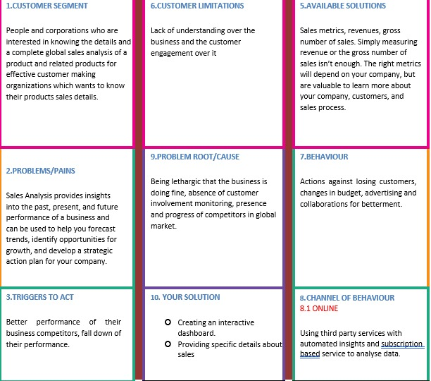

**Fig 1.4.Problem Solution fit**

**REQUIREMENT ANALYSIS**

**4.1 FUNCTIONAL REQUIREMENT**

Following are the functional requirements of the proposed solution.

|  |  |  |
| --- | --- | --- |
| **FR No.** | **Functional Requirement (Epic)** | **Sub Requirement (Story / Sub-Task)** |
| FR-1 | Store Registration | Registration through Form Registration through Gmail  Registration through Store Name |
| FR-2 | Store Confirmation | Confirmation via Email |
| FR-3 | Free Trial Access and | Need to add card Details |
| FR-4 | Subscription Plan and payment | Choose the preferred plan (monthly and Yearly) |
| FR-5 | Data Upload and Preparation | Upload the store-prepared data  Confirm the data Uploaded with the message Cleaning the outliers, duplication and void data |
| FR-6 | Useful Insights Dashboard | UI shows useful Insights to improve the sales Dashboard for Store includes Sale-products, Customer Interest, category wise sales, and Useful insight to  improve sales. |

**4.2 NON-FUNCTIONAL REQUIREMENTS**

Following are the non-functional requirements of the proposed solution.

|  |  |  |
| --- | --- | --- |
| **FR No.** | **Non-Functional Requirement** | **Description** |
| NFR-1 | **Usability** | To suggest very good insights and simplify the  Dashboard to understand the products easily. |
| NFR-2 | **Security** | To provide secured storage for their sales data Uploaded, login, and store details that are used  here. |
| NFR-3 | **Reliability** | A robust type of application can be deployed to  ensure reliability. |
| NFR-4 | **Performance** | Application can be available 24 hours a day  anywhere and without delay. |
| NFR-5 | **Availability** | It must be available to all users both who accessed  the subscription and the free trial. |
| NFR-6 | **Scalability** | Deployed application must be scalable to support  the n number of users and data uploaded. |

**PROJECT DESIGN**

**5.1 DATA FLOW DIAGRAMS**

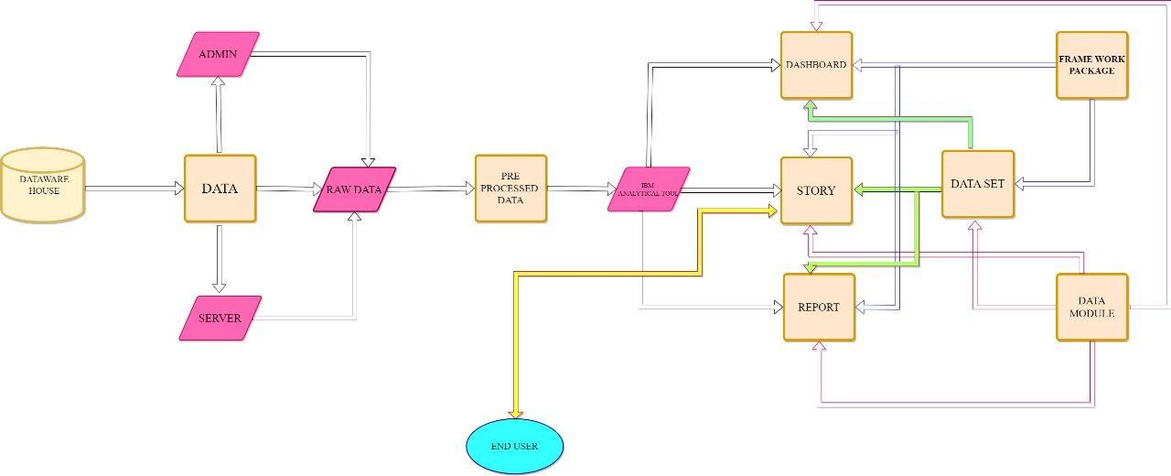

**Fig 2.1.Data Flow Diagram**

**5.2 SOLUTION & TECHNICAL ARCHITECTURE**

The Software Architecture Definition (SAD) document describes the subsystems and components of the solution by presenting a number of architectural views. Each view shows a different aspect of the system to address different concerns and is described in a separate section.

Technical Architecture (TA) is a form of IT architecture that is used to design computer systems. It involves the development of a technical blueprint with regard to the arrangement, interaction, and interdependence of all elements so that system-relevant requirements are met.

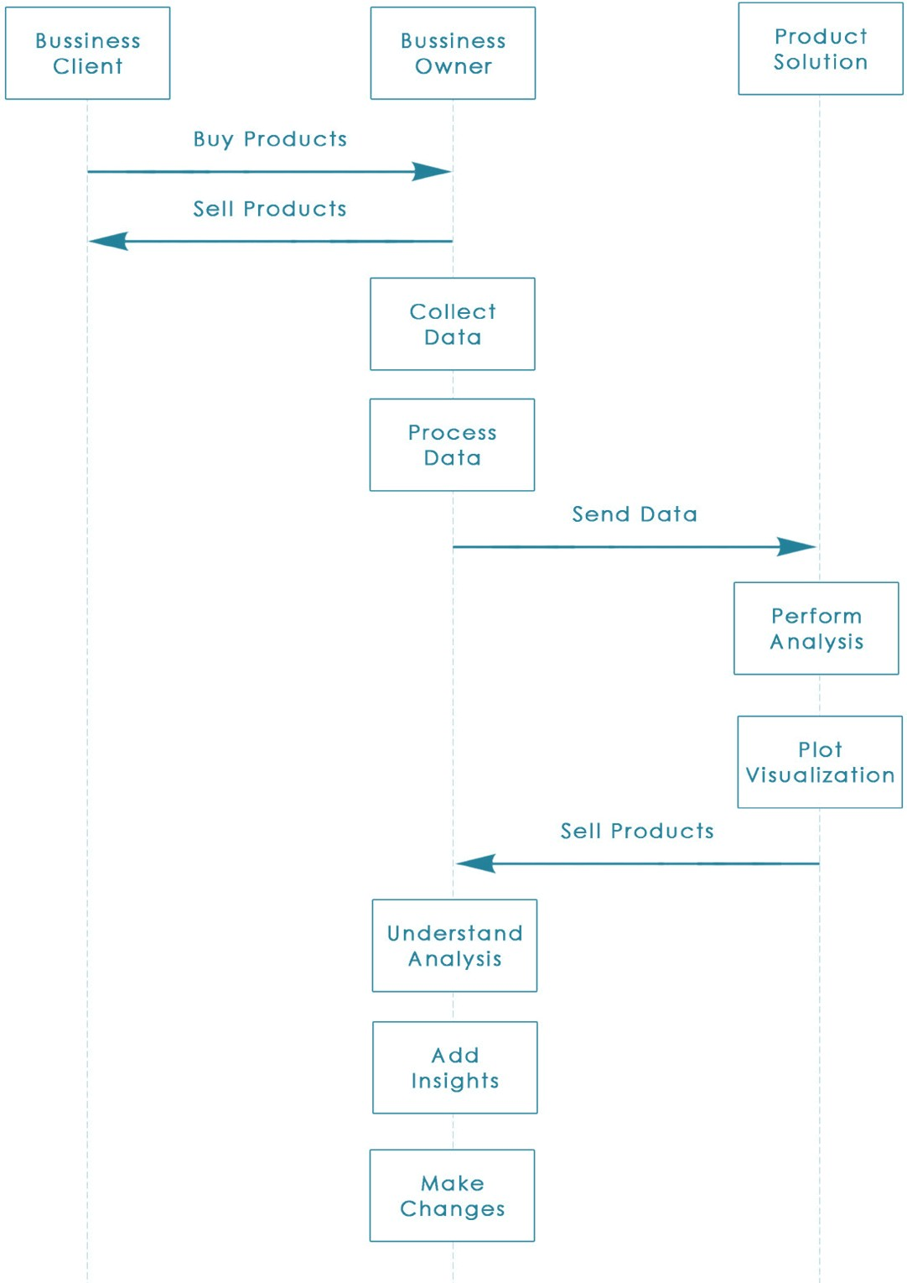

**Fig 2.2. Architecture diagram**

**5.3 USER STORIES**

|  |  |  |  |  |  |  |
| --- | --- | --- | --- | --- | --- | --- |
| **User Type** | **Functional**  **Requirement (Epic)** | **User Story Number** | **User Story / Task** | **Acceptance criteria** | **Priority** | **Release** |
| Customer (Mobile user) | Registration | USN-1 | As a user, I can register for the application by entering my email, password, and confirming my password. | I can access my account / dashboard | High | Sprint-1 |
|  |  | USN-2 | As a user, I will receive confirmation email once I have registered for the application | I can receive confirmation email & click confirm | High | Sprint-1 |
|  |  | USN-3 | As a user, I can register for the application through Store name | I can register & access the dashboard with Store details | High | Sprint-2 |
|  |  | USN-4 | As a user, I can register for the application through Gmail | If Gmail and allows the access | low | Sprint-4 |
|  | Login | USN-5 | As a user, I can log into the application by entering email & password | By correct credentials compared with registered storage | High | Sprint-1 |
|  | Dashboard | USN-6 | As a User I can access the dashboard using the data uploaded. | I valid user then access the dashboards and insights | Medium | Sprint-3 |
| Customer (Web user) | Registration | USN-7 | As a user, I register and login through any browser | If credentials are correct then allow the user | High | Sprint-2 |
| Customer Care Executive | Login | USN-8 | As an executive, I clear the customer’s doubts by chats and if need through voice. | As customer feedback their problem solved. | low | Sprint-4 |
| Administrator | Login | USN-9 | As an admin, I login the system Initially | If credentelias correct then allow access all. | High | Sprint-4 |
|  | Registration Confirm | USN-10 | Admin need to confirm the registering user | If details are enough and correct | Medium | Sprint-3 |
|  | Data Collection | USN-11 | Collect the data from User | Data are correct format | low | Sprint-4 |
|  | Insight’s return | USN-12 | Insights to increase the sales and customer feedback to improve overall | Insights are reliable then allow to users | High | Sprint-1 |

**PROJECT PLANNING & SCHEDULING**

**6.1 SPRINT PLANNING & ESTIMATION**

|  |  |  |  |  |  |  |
| --- | --- | --- | --- | --- | --- | --- |
| **Sprint** | **Functional**  **Requirement (Epic)** | **User**  **Story**  **Number** | **User Story / Task** | **Story Points** | **Priority** | **Team Members** |
| Sprin 1 | Registration | USN-1 | As a user, I can register for the application by entering my store_name,email, password, and confirming my password. | 8 | High | 2 |
| Sprint 1 |  | USN-2 | As a user, I will receive confirmation email once  after successful registration for the application. | 6 | High | 1 |
| Sprint 2 | Login | USN-3 | As a user, I can log into the application by entering email & password | 6 | High | 1 |
| Sprint 2 |  | USN-4 | As an admin , I need to authenticate the user | 6 | Medium | 1 |
| Sprint 1 | Dashboard | USN-5 | As a User, I need to upload the data | 6 | High | 2 |
| Sprint 3 |  | USN-6 | As an admin, I need to set constraints to files uploaded | 4 | Medium | 3 |
| Sprint 4 |  | USN-7 | In dashboard graphs and piecharts used to show analysis | 12 | Medium | 2 |
| Sprint 3 |  | USN-8 | Filter option to include filter for every graph | 4 | Low | 2 |
| Sprint 2 | ML model | USN-9 | As an admin , I need to train the model | 8 | High | 4 |
| Sprint 3 |  | USN-10 | Model need to do sales prediction and give Insights | 6 | Medium | 4 |
| Sprint 3 |  | USN-11 | Insights are displayed in UI to the user | 6 | High | 2 |
| **Sprint** | **Functional**  **Requirement (Epic)** | **User**  **Story**  **Number** | **User Story / Task** | **Story Points** | **Priority** | **Team Members** |
| Sprint 4 |  | USN-12 | As a user, need to logout the system | 8 | Low | 1 |

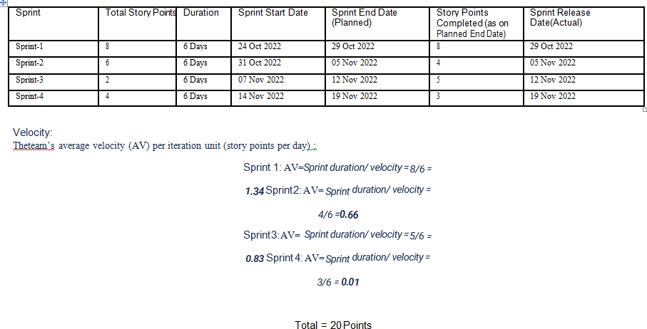**6.2 SPRINT DELIVERY SCHEDULE**

**Fig 3.1. Sprint Delivery Schedule**

**6.3 REPORTS FROM JIRA**

Agile JIRA Reports deliver value to customers faster with real-time insightsat your fingertips. Jira Software enables teams to make data- driven decisions with agile reports, dashboards, and more.

Velocity Chart is how a scrum team measures the amount of work they can complete in a typical sprint. Velocity is measured historically, from one sprint to the next. By tracking the number of story points the team can complete according to their own definition of done, they can build up a reliable and predictable sense of how long it will take them to complete new stories based on their relative point value.

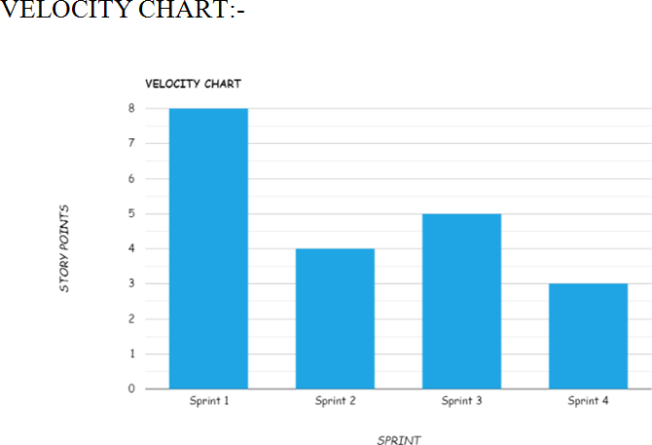 A Burndown Chart shows the team’s progress toward completing all of the points they agreed to complete within a single sprint. This chart starts with the total number of points the team has taken on for the sprint, and tracks on a day-to-day basis how many of those points have been completed and is ready for the sprint demo.

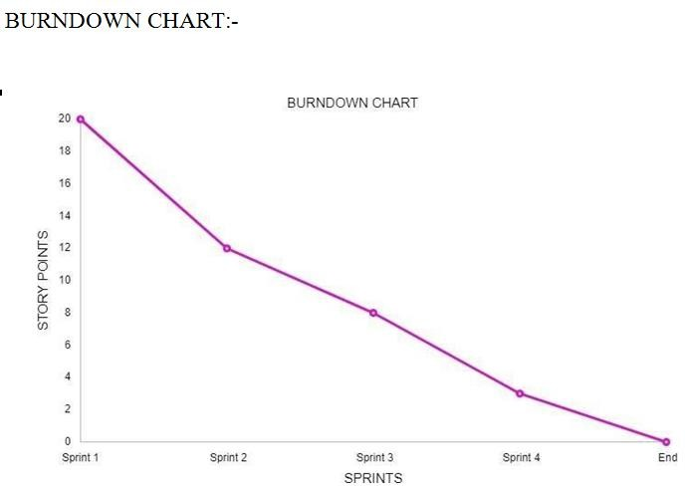

**CODING & SOLUTIONING**

**7.1 FEATURE 1 :**

**HTML FILE :**

<!DOCTYPE html>

<html lang="en">

<head>

<meta charset="UTF-8">

<meta http-equiv="X-UA-Compatible" content=""IE=edge">

<meta name="viewport" content="width"=device-width,initial-scale=1.0">

<title>Data Analytics</title>

<link rel="stylesheet" type="text/css" href="style.css">

<link href="https://cdn.jsdelivr.net/npm/bootstrap@5.2.2/dist/css/bootstrap.min.css" rel="stylesheet" integrity="sha384-Zenh87qX5JnK2Jl0vWa8Ck2rdkQ2Bzep5IDxbcnCeuOxjzrPF/et3URy9Bv1WTRi" crossorigin="anonymous">

</head>

</head>

<body>

<!-----Navbar-->

<div class="container-fluid col-10">

<nav class="navbar navbar-expand-lg" id="Navbar">

<b class="bold"> IBM PROJECT DATA ANALYTICS <H6> PNT2022TMID02707 </H6></b>

<button class="navbar-toggler" type="button"

data-bs-toggle="collapse" data-bs-target="#menu">

<svg xmlns="http://www.w3.org/2000/svg" width="16" height="16" fill="currentColor" class="bi bi-list" viewBox="0 0 16 16">

<path fill-rule="evenodd" d="M2.5 12a.5.5 0 0 1 .5-.5h10a.5.5 0 0 1 0 1H3a.5.5 0 0 1-.5-.5zm0-4a.5.5 0 0 1 .5-.5h10a.5.5 0 0 1 0 1H3a.5.5 0 0 1-.5-.5zm0-4a.5.5 0 0 1 .5-.5h10a.5.5 0 0 1 0 1H3a.5.5 0 0 1-.5-.5z"/>

</svg>

</button>

<div class="collapse navbar-collapse" id="menu">

<ul class="navbar-nav ms-auto mb-lg-0">

<li class="nav-item">

<a class="nav-link" href="#HOME"> HOME</a>

</li>

<li class="nav-item">

<a class="nav-link" href="#DASHBOARD">TEMPLATES</a>

</li>

<li class="nav-item">

<a class="nav-link" href="#ABOUT">GALLERY</a>

</li>

<li class="nav-item">

<a class="nav-link" href="#CONTACT">CONTACT</a>

</li>

<li class="nav-item">

<a class="nav-link" href="#REFERENCE">REFERENCE</a>

</li>

</ul>

</div>

</nav>

<!---Homepage-->

<section id="HOME">

<div class="row">

<div class="col-lg-6 col-md-6 col-12 order-1 pt-5">

<h1 class="display-4"> Global Sales<br><span>Data Analytics</span> </h1>

<p class="my-lg-2 my-3">

Data Analytics refers to the process of collecting, organizing, analysing, and transforming

any type of raw data into a piece of comprehensive information with the ultimate goal of

increasing the performance of a business or organization.

This project is about Global Sales Data Analytics, in which we have created 15 Templates to

showcase the Trends and Patterns in the Dataset (2011-2014) provided. The Dataset contains

51291 Rows and 24 Columns.</p>

<P>

</p>

</div>

<div class="col-lg-6 col-md-6 col-12 py-lg-0 py-3 order-sm-2">

<img src="https://www.freevector.com/uploads/vector/preview/20655/7.1-05.jpg" class="img-fluid">

</div>

</div>

</section>

<!----Dashboard---->

<section id="DASHBOARD">

<div class="row">

<div class="col-lg-6 col-md-6 col-12 py-lg-0 py-3 order-sm-2">

<img src="https://sp-ao.shortpixel.ai/client/to_webp,q_glossy,ret_img/https://www.analyticsinsight.net/wp-content/uploads/2021/07/Data-Visualization-1440x564_c.jpg" class="img-fluid">

</div>

<div class="col-lg-6 col-md-6 col-12 order-1 pt-5">

<h6 style="font-size: 50px"> GLOBAL SUPERSTORE </h6>

<h1 class="display-5"> <span> DATASET</span></h1>

<P> A collection of data is known as a data set (or dataset). In the case of tabular data, a data set relates to one or more database tables, where each row refers to a

specific record in the corresponding data set and each column to a single variable. </P>

<h6 style="font-size: 30px"> The dashboard we worked for the following title:</h6>

<ol class="types">

<p style="color:darkblue">

<li>Segment Wise Sales, Profit And Quantity</li>

<li>Sales By Market</li>

<li>Sales By Category And Sales By Region</li>

<li>Country Wise Sales Using Map Points</li>

<li> Sub Category Wise Sales And Profits Using Line And Bar Chart</li>

<li>Sales Vs Profit Scatter Plot With Sub Categories And Regions</li>

<li> Regional Sales And Profit Forecast</li>

<li> Sales Forecast By Order Priority</li>

<li>Sales By Sub Category Analytics</li>

<li> Sales By Segment Analysis</li>

<li> Sales Vs Profit By Countries</li>

<li> Regional Quantity And Sales Using Radar Chart</li>

<li> Country Wise Sales Vs Profit Using Word Cloud</li>

<li> Sales Dashboard</li>

</p >

</ol>

<a href="slide1.html">

<button class="btn btn-primary my-lg-3 my-3">View Chart</button>

</a>

</div>

</div>

**CSS FILE :**

*{

margin: 0;

padding: 0;

font-family: sans-serif;

}

.hero{

height: 100%;

width: 100%;

background-image: linear- gradient(rgba(0,0,0,0.4),rgba(0,0,0,0.4)),url(bg3.jpg);

background-position: center; background-size: cover; position: absolute;

}

.form-box{ width: 380px; height: 480px;

position: relative; margin: 6% auto; background: #fff; padding:5px; overflow: hidden;

}

.button-box{ width: 220px;

margin: 35px auto; position: relative;

box-shadow: 0 0 20px 9px #ff61121f; border-radius: 30px;

}

.toggle-btn{

padding: 10px 30px; cursor: pointer; background: transparent; border: 0;

outline: none; position: relative

}

#btn{

top: 0;

left: 0; position:absolute; width: 110px; height: 100%;

background: linear-gradient(to right, #ff105f, #ffad06); border-radius: 30px;

transition: .5s; overflow:hidden;

}

.social-icons{ margin: 30px auto;

text-align: center;

}

.social-icons img{ width: 30px; margin: 0 12px;

box-shadow: 0 0 20px 0 #7f7f7f3d; cursor: pointer;

border-radius: 50%;

}

.input-group{ top: 180px;

position: absolute; width: 280px; transition: .5s;

}

.input-field{ width: 100%;

padding: 10px 0;

margin: 5px 0;

border-left: 0;

border-top: 0;

border-right: 0;

border-bottom: 1px solid #999; outline: none;

background: transparent;

}

.submit-btn{ width: 85%;

padding: 10px 30px; cursor: pointer; display: block;

margin :auto;

background: linear-gradient(to right, #ff105f, #ffad06); border: 0;

outline: none; border-radius: 30px;

}

.check-box{

margin: 30px 10px 30px 0;

}

span{

color: #777; font-size: 12px; bottom: 68px;

position: absolute;

}

#login{

left: 50px;

}

#register { left: 450px;

}

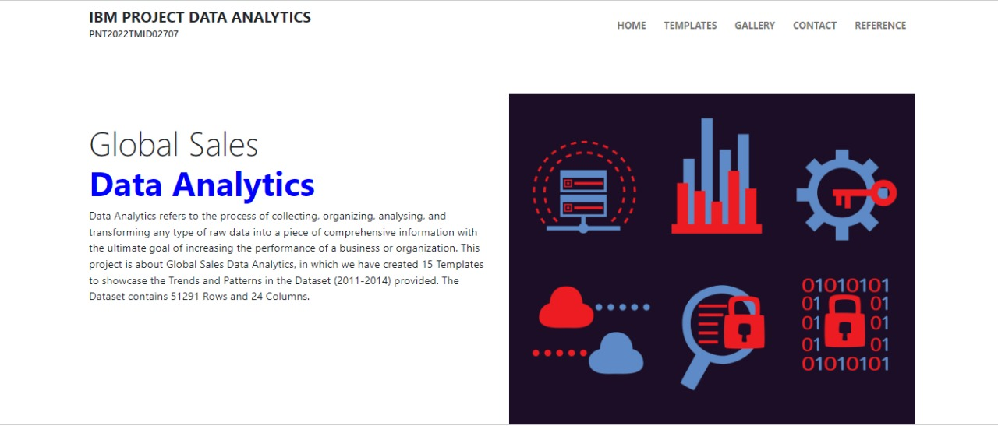

## Feature 2

**UNDERSTANDING TNE DATASET :**

* + Once we have download the [Dataset](https://www.kaggle.com/apoorvaappz/global-super-store-dataset), the rows you see are the details of the order done online by people across the globe in the time frame 1-jan-2011 to 31-dec-2014. There are no missing values in the majority of columns except postal code, you can drop it if not required.

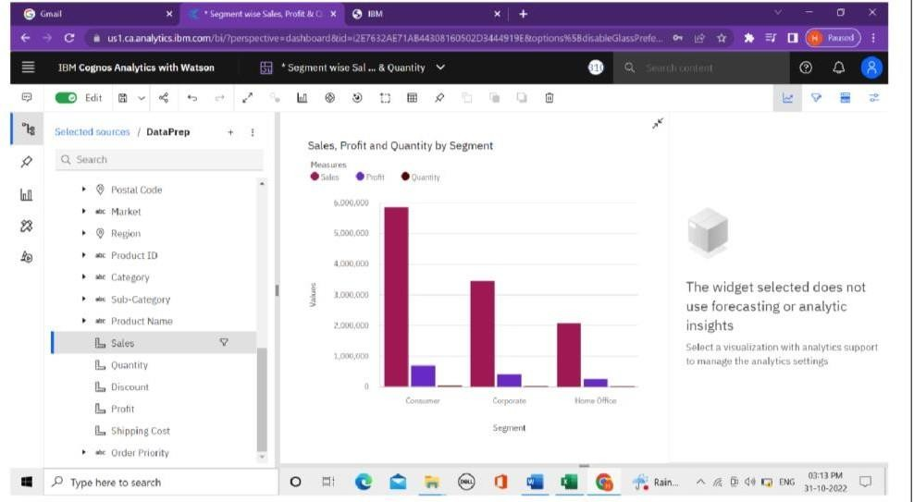 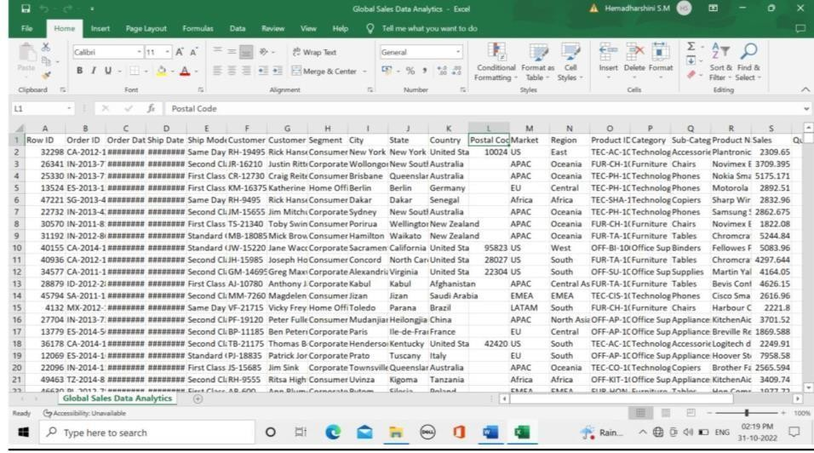

## LOADING THE DATASET:

* Before we can build a view and analyze your data, we must first connect the data to IBM Cognos.
* Cognos supports connecting to a wide variety of data, stored in a variety of places.
* The data might be stored on your computer in a spreadsheet or a text file, or in a big data, relational, or cube (multidimensional) database on a server in your enterprise.
* In our case, we will be using a spreadsheet or text file for making our analysis.

## PREPARE THE DATASET :

* Once we load the data, we need to Prepare the data.
* 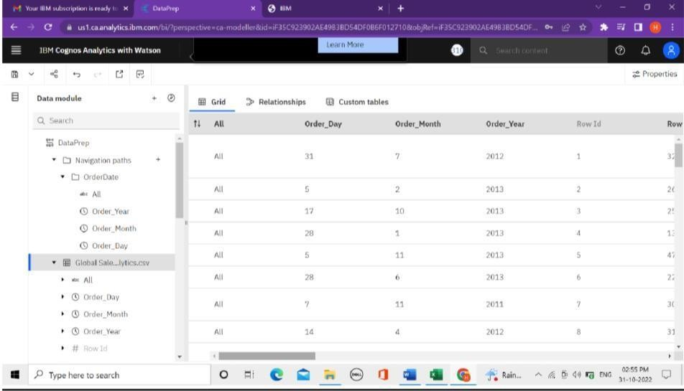Prepare Calculations of Year, Month, Day fields and also the related Navigation path Create a Few more Calculations – Target Sales, Min Sales, Max Sales, Middle Range Sales.

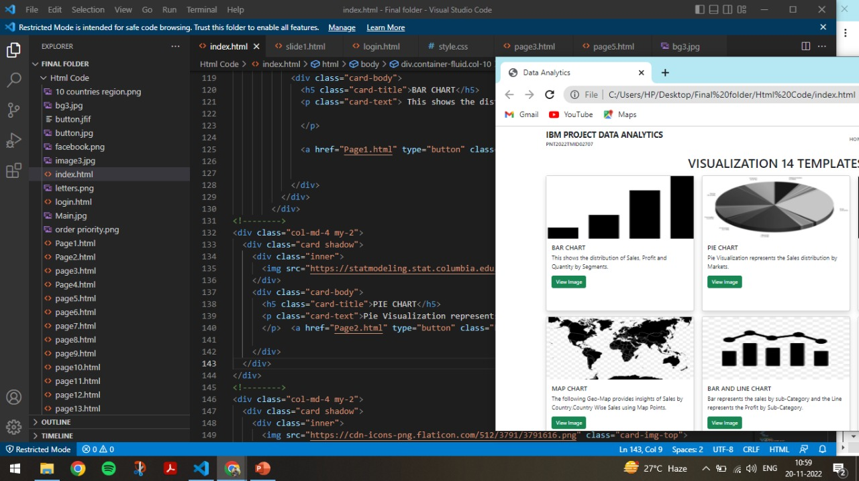

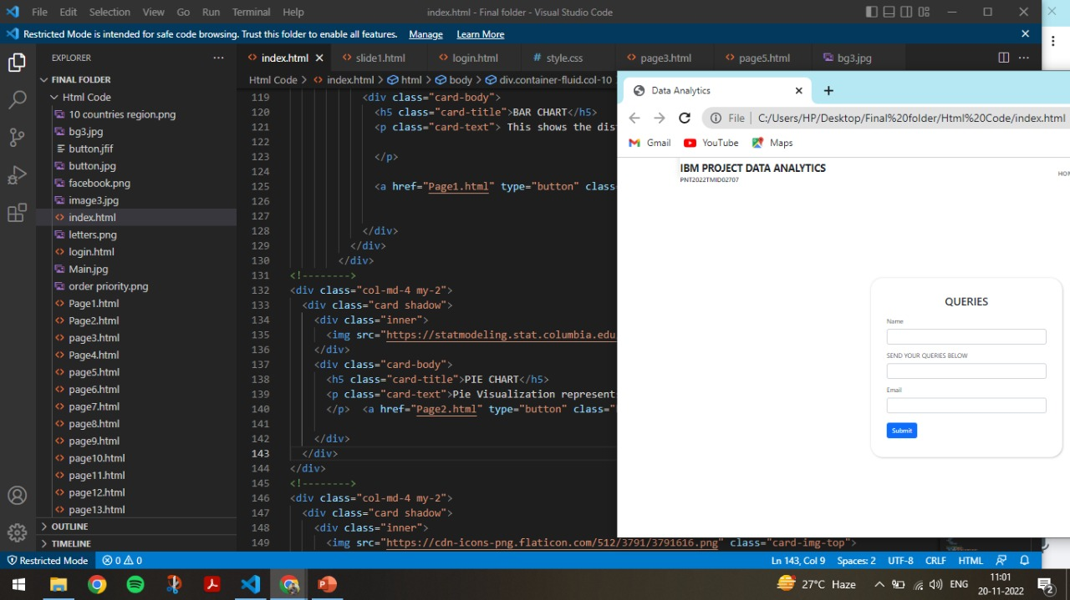

**TESTING**

**8.1 TEST CASES**

|  |  |  |  |  |  |
| --- | --- | --- | --- | --- | --- |
| **Test case ID** | **Test Scenario** | **Steps To Execute** | **Expected Result** | **Status** | **Executed By** |
| Register Page_TC_ OO1 | Authenticated user is able to see the Login/Register popup when they landed on  Web Application | 1. Enter URL and click go. 2. Verify login/register popup displayed or not | Login/Signup popup should display | Pass | BHARATH |
| RegisterPa ge_TC_OO 2 | Verify the UI elements in Login/Register popup | 1. Enter URL and click go 2. Verify login/Singup popup with below UI elements:   a.email text box b.password text box c.Login button d.Register button  e.Remember password checkbox | Application should show below UI elements:  a.email text box b.password text box  c.Login button with orange colour  d.Register button e.Remember password | Pass | HARISH NJ |
| LoginPage  _TC_OO3 | Verify user is able to log into application with InValid credentials | 1. Enter URL (Global Sales Data Analytics Web Application)   and click go   1. Enter InValid user id/email in Email text box 2. Enter valid password in password text box 3. Click on login button | User should navigate to the homepage | Fail | KANISHKA |
| LoginPage  _TC_OO4 | Verify user is able to log into application with Valid credentials | 1.Enter URL  (Global Sales Data Analytics Web Application )  and click go 2.Enter Valid  userid/email in Email text box   1. Enter valid password in password text box 2. Click on login button | Application should show 'Redirecting to the Homepage ' validation message. | Pass | KANISHKA |

|  |  |  |  |  |  |
| --- | --- | --- | --- | --- | --- |
| LoginPage  _TC_OO5 | Verify user is able to log into application with InValid credentials | 1.Enter URL(Global Sales Data Analytics Web Application )  and click go 2.Enter InValid  username/email in Email text box   1. Enter Invalid password in password text box 2. Click on login button | Application should show 'Incorrect email or password ' validation message. | Pass | AZAGHU  VENKATESH |
| LoginPage  _TC_OO6 | Verify user is able to log into application with InValid credentials | 1.Enter URL(Global Sales Data Analytics Web Application )  and click go 2.Enter InValid  username/email in Email text box  3.Enter Invalid password in password text box 4.Click on login button | Application should show 'Incorrect email or password ' validation message. | Pass | HARISH NJ |

**8.2 USER ACCEPTANCE TESTING**

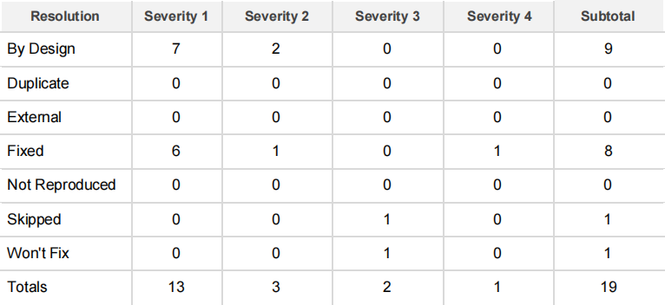

**RESULTS**

**9.1 PERFORMANCE METRICS**

Sales metrics are data points that measure and evaluate an individual, team or company's sales performance over a period of time. In the big picture, sales metrics help an organization analyze the success of its sales initiatives, as well as identify areas that might need improvement.

1. **Global Superstore Data is Uploaded to IBM Cognos Analytics Tool.**

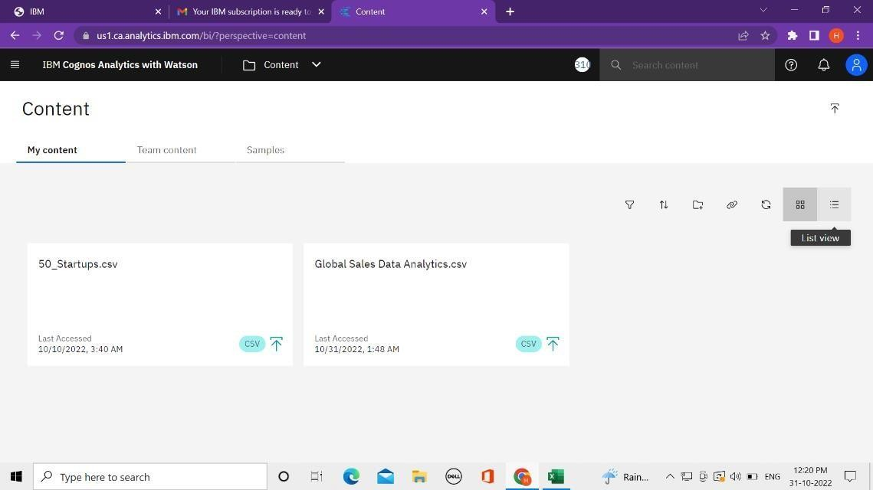

1. **Global Superstore Dataset is Prepared by analysing the Columns & Rows**

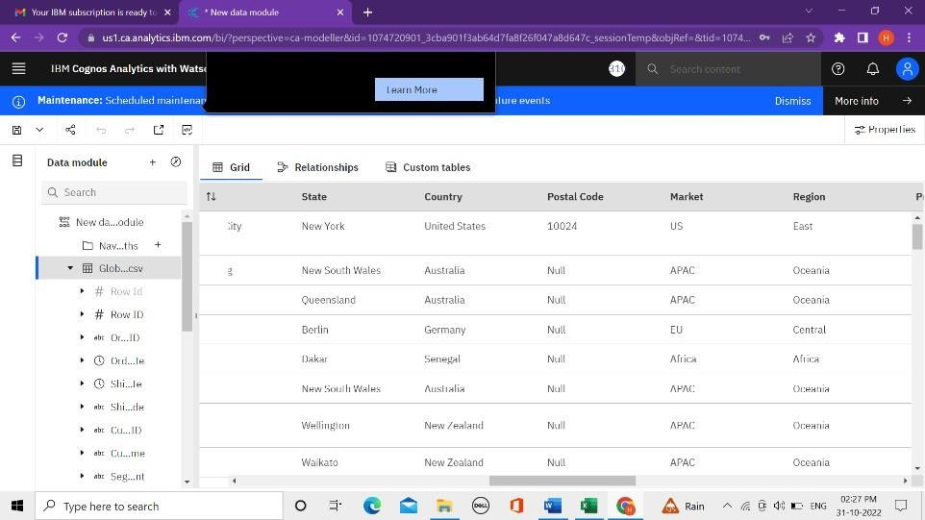

**Date Calculations has done in the Dataset and Navigation path is shown.**

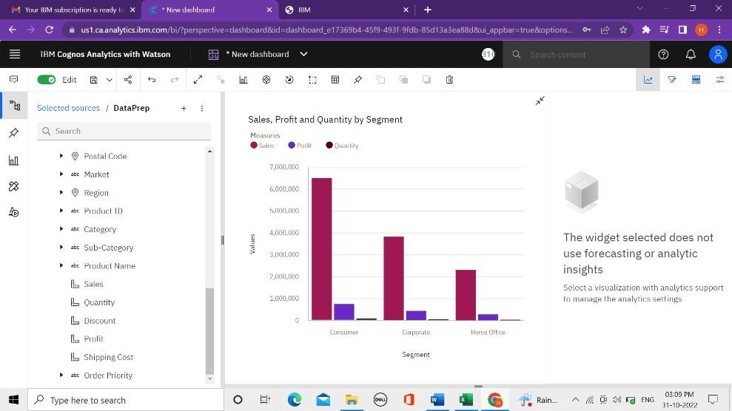

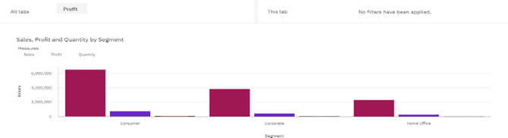**This Char shows the Segment wise Sales, Profit and Quantity**

**Pie Chart to showcase Sales by Order Priority and Sales by Market**

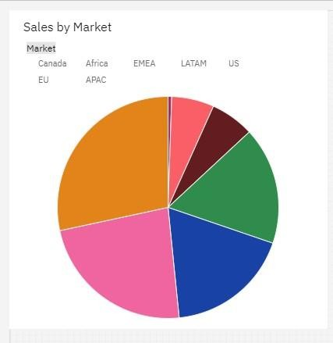

**A Tree Map Chart to present Sales by Sub-Category.**

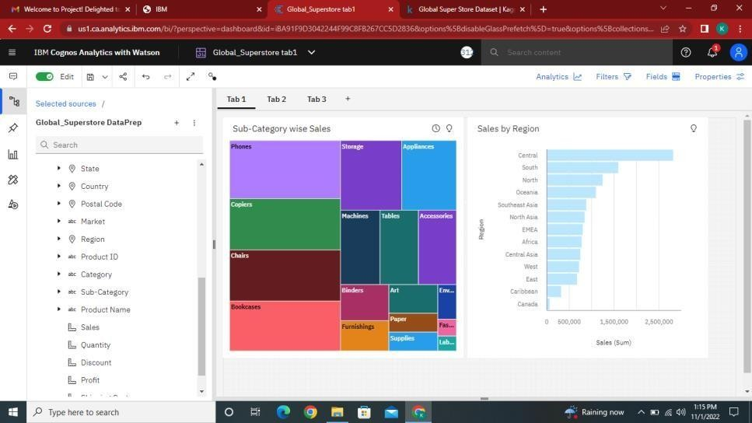

**Using a Bubble chart to represent Sales by Region by the Sales Order**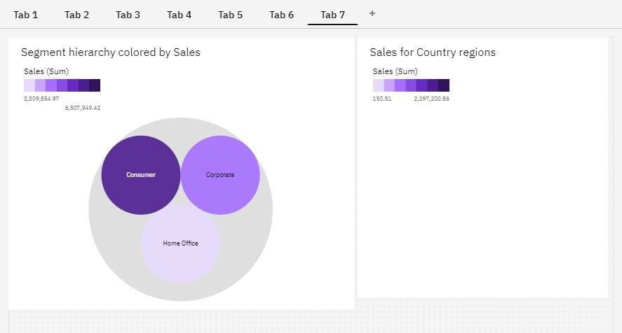

**Present Regional Sales using Map Country points – This Template is showcasing Top 10 countries.**

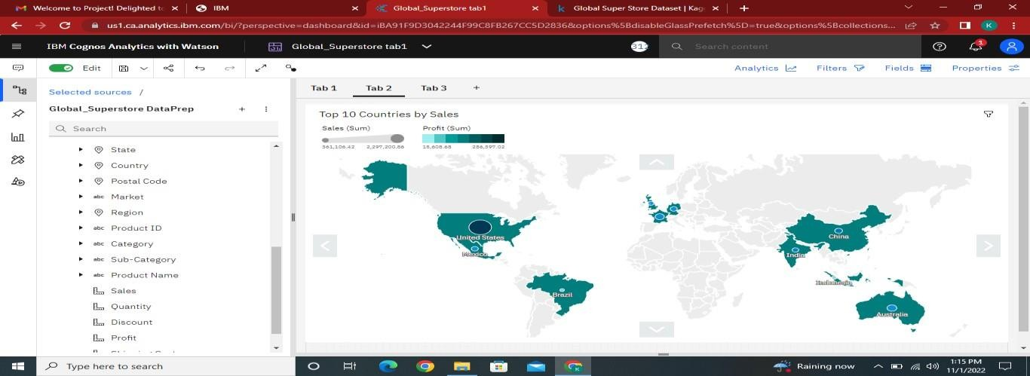

**Present Sales (Bar), Profit (line) by Sub-Category using Line and Column Chart.**

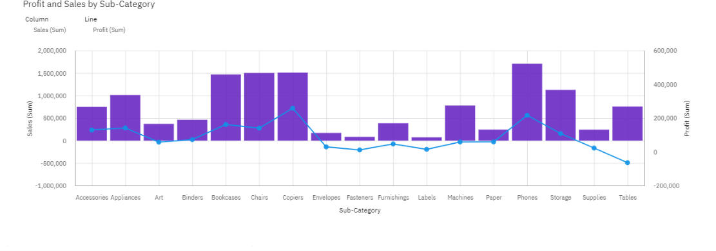

**Sales vs Profit Scatter Plot with Sub-Category points and Region in Colour is shown.**

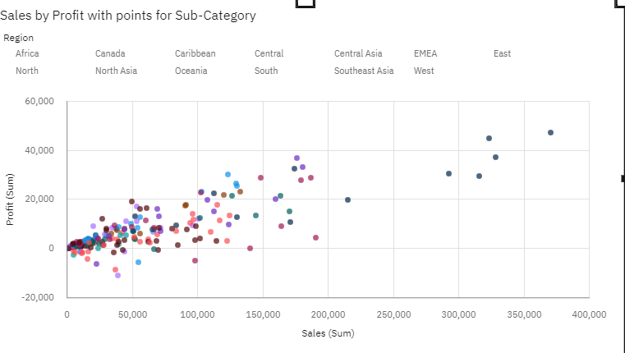

**Sales and Profit Forecast by Month Country as Region and Region as Filter.**

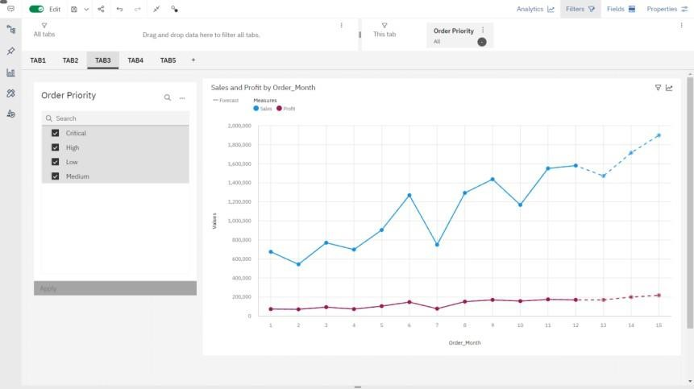

**Sales vs Profit forecast by Month by Order Priority.**

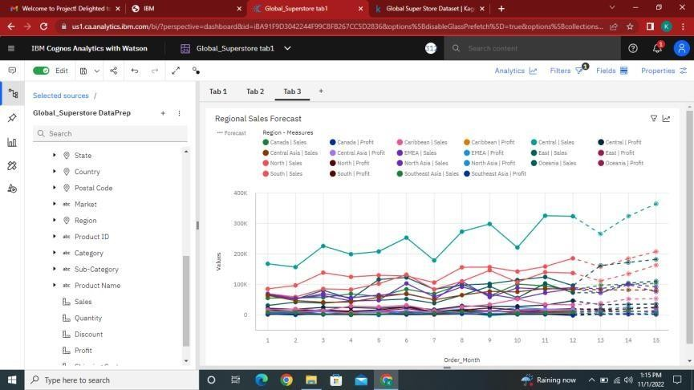

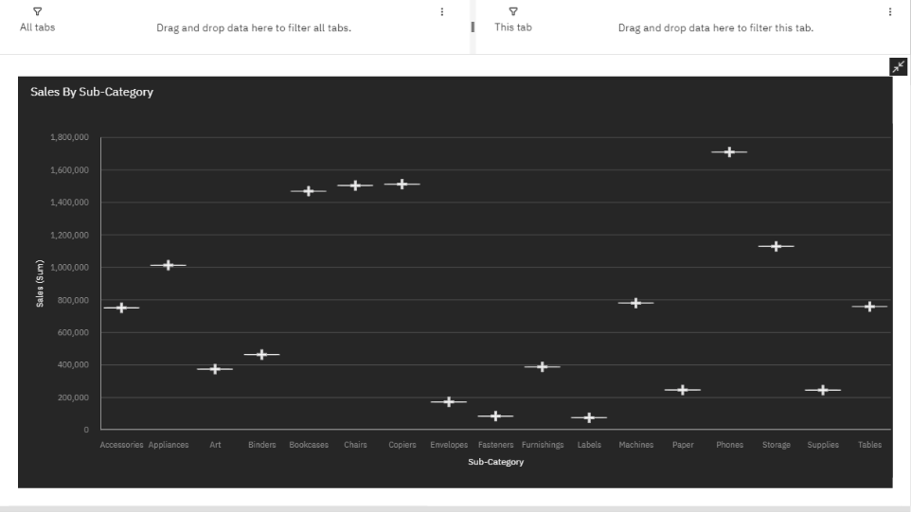**Show the Min, Max, and Avg Sales by Sub-Category using the Box plot.**

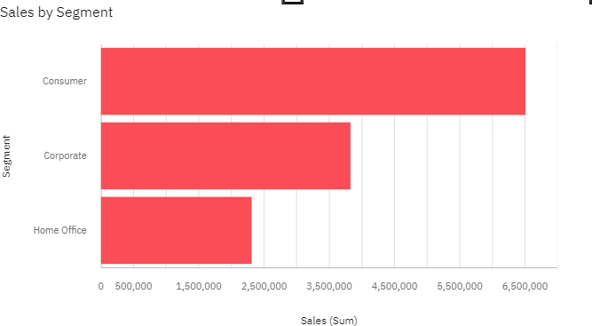**By setting a 10% extra Target for Sales Present Segment-wise Sales use Bullet Chart.**

**Present Sales using Hierarchy Bubbles by Market / Regio**

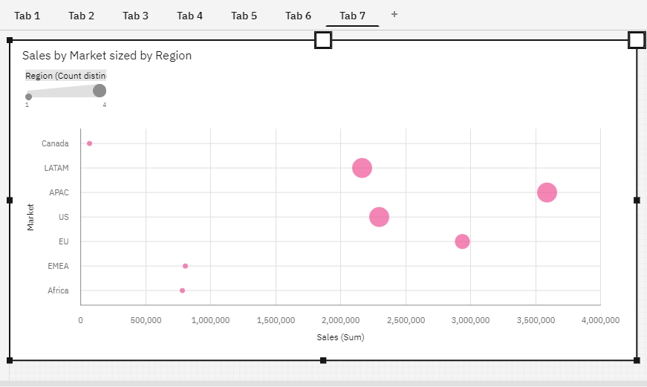

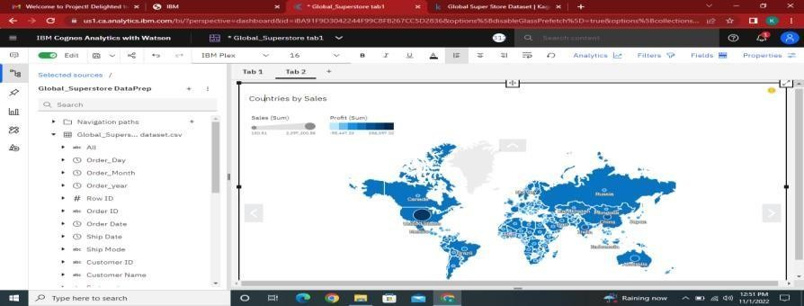**Using a Legacy Map Present Sales vs Profit by Country / Region.**

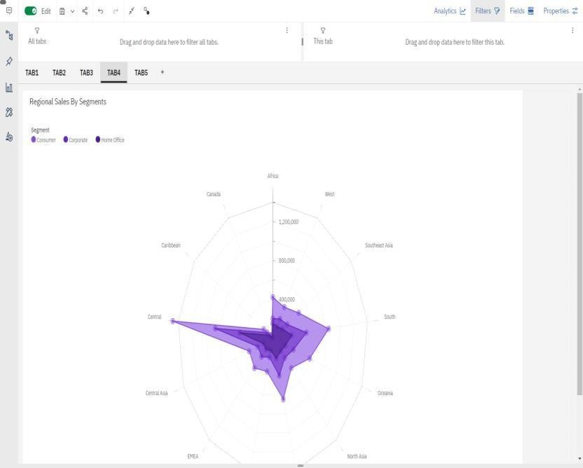

**Showcase Quantity Sold by Radar Chart across various Regions.**

## Present Monthly Sales by Sub-Category using Waterfall chart.

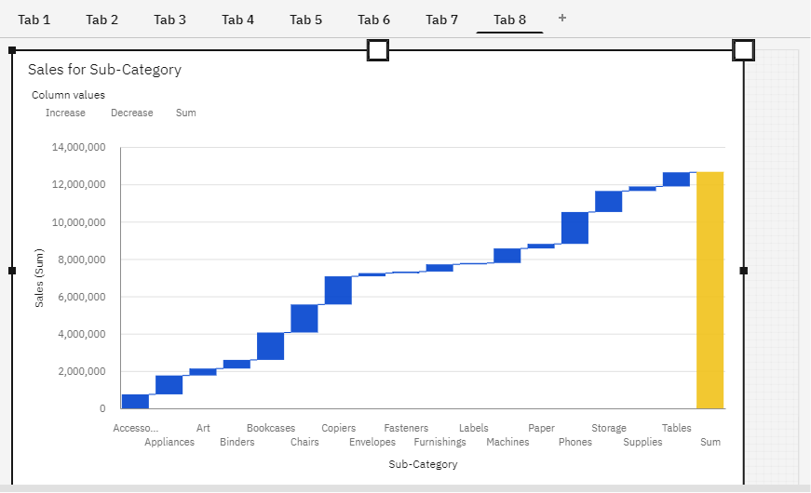

**Present Sales Vs Profit of Countries by Word Cloud.**

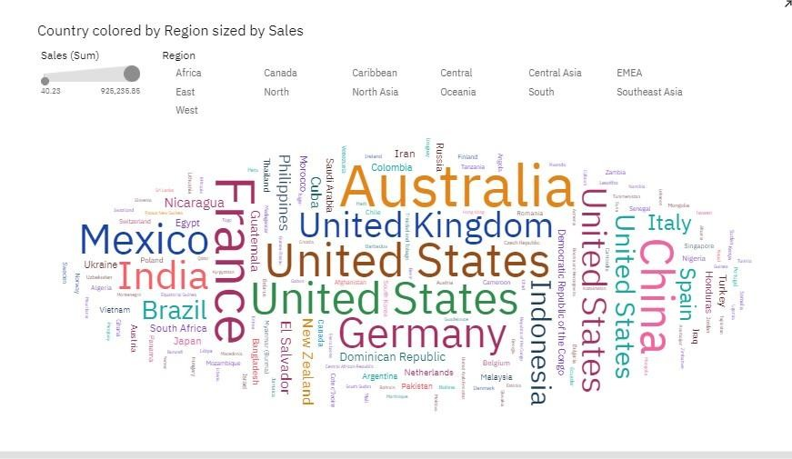

**Sales dashboard with Summary Card**

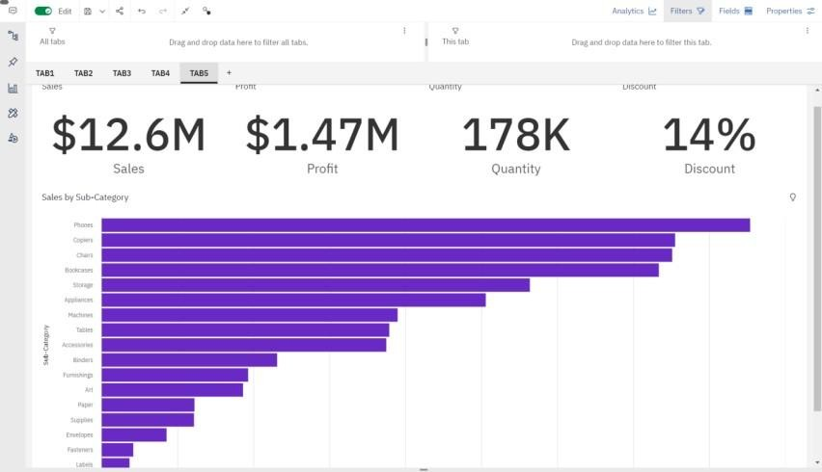

**ADVANTAGES & DISADVANTAGES**

**Advantages of Data Analytics:**

➨It detects and correct the errors from data sets with the help of data cleansing. This helps in improving quality of data and consecutively benefits both customers and institutions such as banks, insurance and finance companies.

➨It removes duplicate information from data sets and hence saves large amount of memory space. This decreases cost to the company.

➨It helps in displaying relevant advertisements on the online shopping websites based on historic data and purchase behavior of the users. Machine learning algorithms are applied for the same. This helps in increasing revenue and productivity of the companies.

➨It reduces banking risks by identifying probable fraudulent customers based on historic data analysis. This helps institutes in deciding whether to issue loan or credit cards to the applicants or not.

**Following are the disadvantages of data Analytics:**

➨This may breach privacy of the customers as their information such as purchases, online transactions; subscriptions are visible to their parent companies. The companies may exchange these useful customer databases for their mutual benefits.

➨The cost of data analytics tools vary based on applications and features supported. Moreover some of the data analytics tools are complex to use and require training. This increases cost to the company willing to adopt data analytics tools or software.

➨The information obtained using data analytics can also be misused against group of people of certain country or community or caste.

➨It is very difficult to select the right data analytics tools. This is due to the fact that it requires knowledge of the tools and their accuracy in analyzing the relevant data as per applications.

**CONCLUSION**

Data analytics helps companies develop new products/services that will have better responses from customers and increase their sales revenue and profits by analyzing customer preferences through surveys. This will help them create new products/services that will have a better response from customers and increase their sales revenue and profits. Thus, a Web Application which contains multiple Data Visualization Charts is created. Data visualization is the graphical representation of information and data in a pictorial or graphical format (Example: charts, graphs, and maps). Thus, this project provides an accessible way to see and understand trends, patterns in Global Superstore Data collected from 2011 to 2014 worldwide.

**FUTURE SCOPE**

In Future or in need of the advancement of this Global Sales Data Analytics project, one can create more Visualization Dashboards by looking at the Dataset carefully. Hence, the Customer Analysis and Product Analysis is enhanced. Data analytics can be used in many ways. However, the main purpose of data analytics is to help companies make better business decisions and improve their overall performance. There are various ways in which data analytics can be used:

Helps companies track past trends and patterns to predict future trends and patterns so that they do not miss out on opportunities for increased sales revenue or profits. For example, if a company wants to know if there is an increase in the sales of its products or services, it may use data analytics to analyze the past trends and patterns of its product/service sales on an annual basis to understand if there is any significant increase or decrease in sales revenue from previous years.

* Monitor social media activities to help them know how their customers are reacting before launching a new product or service which has a good response from customers. This will help them create new products/services that will have a better response from customers and increase their sales revenue and profits.
* Data analytics helps companies improve operations by analyzing past trends and patterns to predict future trends and patterns so that they do not miss out on opportunities for increased sales revenue or profits. For example, if a company wants to know if there is an increase in the sales of its products or services, it may use data analytics to analyze the past trends and patterns of its product/service sales on an annual basis to understand if there is any significant increase or decrease in sales revenue from previous years.

**APPENDIX**

**SOURCE CODE :**

**HTML FILE :**

<!DOCTYPE html>

<html lang="en">

  <head>

    <meta charset="UTF-8">

    <meta http-equiv="X-UA-Compatible" content=""IE=edge">

    <meta name="viewport" content="width"=device-width,initial-scale=1.0">

    <title>Data Analytics</title>

    <link rel="stylesheet"  type="text/css"  href="style.css">

    <link href="https://cdn.jsdelivr.net/npm/bootstrap@5.2.2/dist/css/bootstrap.min.css" rel="stylesheet" integrity="sha384-Zenh87qX5JnK2Jl0vWa8Ck2rdkQ2Bzep5IDxbcnCeuOxjzrPF/et3URy9Bv1WTRi" crossorigin="anonymous">

  </head>

  </head>

  <body>

         <!-----Navbar-->

        <div class="container-fluid col-10">

          <nav class="navbar navbar-expand-lg" id="Navbar">

            <b class="bold"> IBM PROJECT DATA ANALYTICS <H6> PNT2022TMID02707 </H6></b>

            <button class="navbar-toggler" type="button"

            data-bs-toggle="collapse" data-bs-target="#menu">

            <svg xmlns="http://www.w3.org/2000/svg" width="16" height="16" fill="currentColor" class="bi bi-list" viewBox="0 0 16 16">

              <path fill-rule="evenodd" d="M2.5 12a.5.5 0 0 1 .5-.5h10a.5.5 0 0 1 0 1H3a.5.5 0 0 1-.5-.5zm0-4a.5.5 0 0 1 .5-.5h10a.5.5 0 0 1 0 1H3a.5.5 0 0 1-.5-.5zm0-4a.5.5 0 0 1 .5-.5h10a.5.5 0 0 1 0 1H3a.5.5 0 0 1-.5-.5z"/>

            </svg>

            </button>

            <div class="collapse navbar-collapse" id="menu">

              <ul class="navbar-nav ms-auto mb-lg-0">

                <li class="nav-item">

                  <a class="nav-link" href="#HOME"> HOME</a>

                </li>

                <li class="nav-item">

                  <a class="nav-link" href="#DASHBOARD">TEMPLATES</a>

                </li>

                <li class="nav-item">

                  <a class="nav-link" href="#ABOUT">GALLERY</a>

                </li>

               <li class="nav-item">

                  <a class="nav-link" href="#CONTACT">CONTACT</a>

                </li>

                <li class="nav-item">

                  <a class="nav-link" href="#REFERENCE">REFERENCE</a>

                </li>

              </ul>

            </div>

          </nav>

          <!---Homepage-->

          <section id="HOME">

            <div class="row">

              <div class="col-lg-6 col-md-6 col-12 order-1 pt-5">

                <h1 class="display-4"> Global Sales<br><span>Data Analytics</span> </h1>

                <p class="my-lg-2 my-3">

                  Data Analytics refers to the process of collecting, organizing, analysing, and transforming

   any type of raw data into a piece of comprehensive information with the ultimate goal of

increasing the performance of a business or organization.

This project is about Global Sales Data Analytics, in which we have created 15 Templates to

showcase the Trends and Patterns in the Dataset (2011-2014) provided. The Dataset contains

51291 Rows and 24 Columns.</p>

                 <P>

                </p>

              </div>

              <div class="col-lg-6 col-md-6 col-12 py-lg-0 py-3 order-sm-2">

                <img src="https://www.freevector.com/uploads/vector/preview/20655/7.1-05.jpg" class="img-fluid">

              </div>

            </div>

          </section>

   <!----Dashboard---->

    <section id="DASHBOARD">

      <div class="row">

        <div class="col-lg-6 col-md-6 col-12 py-lg-0 py-3 order-sm-2">

          <img src="https://sp-ao.shortpixel.ai/client/to_webp,q_glossy,ret_img/https://www.analyticsinsight.net/wp-content/uploads/2021/07/Data-Visualization-1440x564_c.jpg" class="img-fluid">

          </div>

        <div class="col-lg-6 col-md-6 col-12 order-1 pt-5">

          <h6 style="font-size: 50px"> GLOBAL SUPERSTORE </h6>

          <h1 class="display-5"> <span> DATASET</span></h1>

          <P> A collection of data is known as a data set (or dataset). In the case of tabular data, a data set relates to one or more database tables, where each row refers to a

             specific record in the corresponding data set and each column to a single variable. </P>

             <h6 style="font-size: 30px"> The dashboard we worked for the following title:</h6>

            <ol class="types">

              <p style="color:darkblue">

                 <li>Segment Wise Sales, Profit And Quantity</li>

                 <li>Sales By Market</li>

                 <li>Sales By Category And Sales By Region</li>

                 <li>Country Wise Sales Using Map Points</li>

                 <li> Sub Category Wise Sales And Profits Using Line And Bar Chart</li>

                 <li>Sales Vs Profit Scatter Plot With Sub Categories And Regions</li>

                 <li> Regional Sales And Profit Forecast</li>

                 <li> Sales Forecast By Order Priority</li>

                 <li>Sales By Sub Category Analytics</li>

                 <li> Sales By Segment Analysis</li>

                 <li> Sales Vs Profit By Countries</li>

                 <li> Regional Quantity And Sales Using Radar Chart</li>

                 <li> Country Wise Sales Vs Profit Using Word Cloud</li>

                 <li> Sales Dashboard</li>

              </p >

             </ol>

              <a href="slide1.html">

          <button class="btn btn-primary my-lg-3 my-3">View Chart</button>

          </a>

        </div>

        </div>

**CSS FILE :**

*{

margin: 0;

padding: 0;

font-family: sans-serif;

}

.hero{

height: 100%;

width: 100%;

background-image: linear- gradient(rgba(0,0,0,0.4),rgba(0,0,0,0.4)),url(bg3.jpg);

background-position: center; background-size: cover; position: absolute;

}

.form-box{ width: 380px; height: 480px;

position: relative; margin: 6% auto; background: #fff; padding:5px; overflow: hidden;

}

.button-box{ width: 220px;

margin: 35px auto; position: relative;

box-shadow: 0 0 20px 9px #ff61121f; border-radius: 30px;

}

.toggle-btn{

padding: 10px 30px; cursor: pointer; background: transparent; border: 0;

outline: none; position: relative

}

#btn{

top: 0;

left: 0; position:absolute; width: 110px; height: 100%;

background: linear-gradient(to right, #ff105f, #ffad06); border-radius: 30px;

transition: .5s; overflow:hidden;

}

.social-icons{ margin: 30px auto;

text-align: center;

}

.social-icons img{ width: 30px; margin: 0 12px;

box-shadow: 0 0 20px 0 #7f7f7f3d; cursor: pointer;

border-radius: 50%;

}

.input-group{ top: 180px;

position: absolute; width: 280px; transition: .5s;

}

.input-field{ width: 100%;

padding: 10px 0;

margin: 5px 0;

border-left: 0;

border-top: 0;

border-right: 0;

border-bottom: 1px solid #999; outline: none;

background: transparent;

}

.submit-btn{ width: 85%;

padding: 10px 30px; cursor: pointer; display: block;

margin :auto;

background: linear-gradient(to right, #ff105f, #ffad06); border: 0;

outline: none; border-radius: 30px;

}

.check-box{

margin: 30px 10px 30px 0;

}

span{

color: #777; font-size: 12px; bottom: 68px;

position: absolute;

}

#login{

left: 50px;

}

#register { left: 450px;

}

**GITHUB & PROJECT DEMO LINK :**

**Github Link :**

[**https://github.com/IBM-EPBL/IBM-Project-16465-1659615097**](https://github.com/IBM-EPBL/IBM-Project-16465-1659615097)